PRACTICE 02 – MEASUREMENTS ON ELEMENTARY SIGNALS
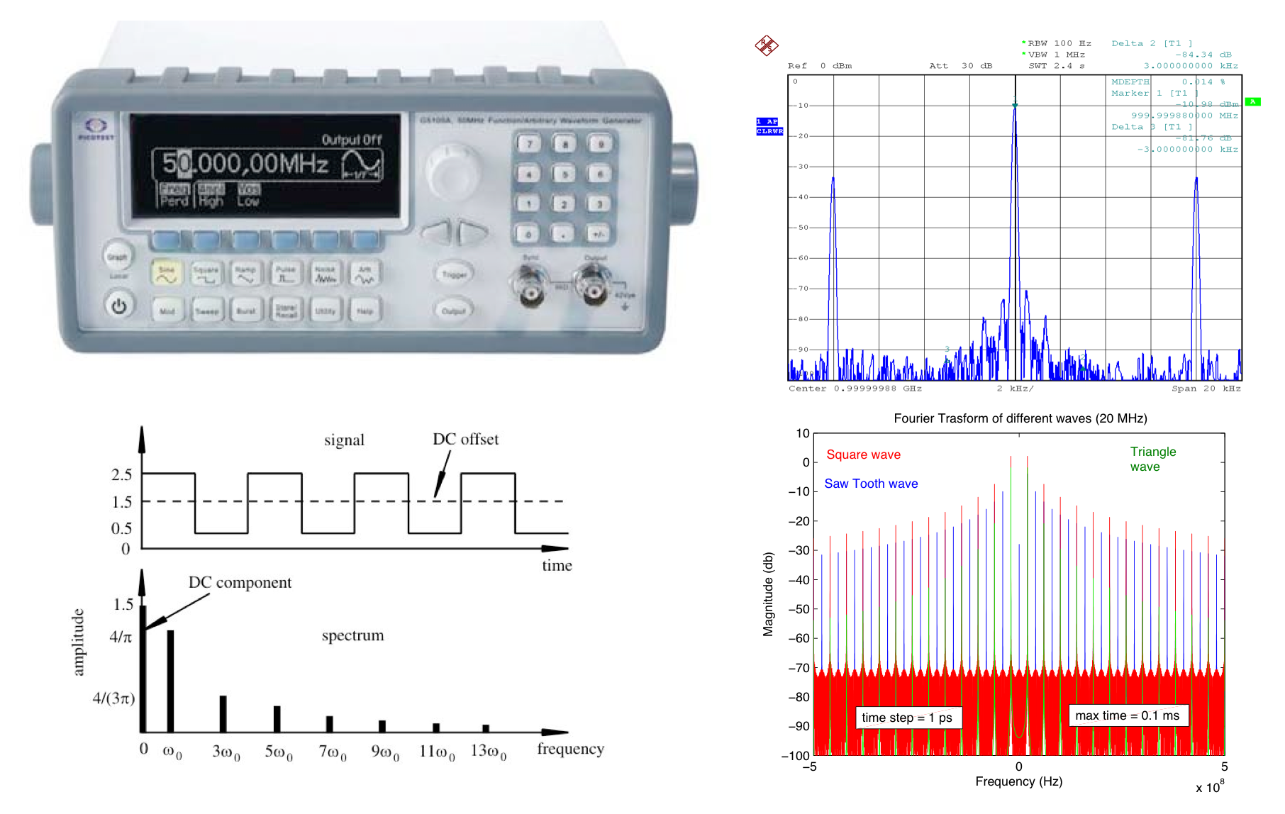

1. Frequency and magnitude measurement of a sinusoidal signal

Use the synthesizer (ROHDE&SCHWARZ SML03 9 kHz 3.3 GHz or Agilent E4432B 250 kHz – 3.0 GHz) to get a sinusoidal signal (1 GHz, 0 dBm) and measure it connecting the synthesizer to the Spectrum Analyzer (SPA) through a RF cable.

1.1. Select Center Freq = 1 GHz, Span = 2GHz. What do you see? (REPORT).

1.2 With the help of markers, measure the frequency and the power of the signal choosing the most appropriate SPA settings in terms of frequency range (FREQ -> START, STOP) and magnitude reference level (AMPT -> REF LEVEL). Save data and comment on the result. (REPORT)

1.3 On the same signal, fix the SPAN to 100 MHz, VBW auto and measure the noise power 30MHz far from the carrier with Detector average and Trace Average (on HP SPA set Detector PK and Average OFF).

Make a table RBW – carrier power – noise power – attenuation – DANL for three different values of RBW (i.e. 300 kHz, 1 MHz, 3 MHz). Repeat the set of measures for a generator power of -10 dBm and -20 dBm. Comment the results. (REPORT)

2. Measure of an amplitude modulated signal with a sinusoidal signal

The synthesizer (ROHDE&SCHWARZ SML03 9 kHz 3.3 GHz or Agilent E4432B 250 kHz – 3.0 GHz) can produce a signal with sinusoidal amplitude modulation according to settings given below.
Signal generator settings (synthesizer)
Carrier frequency 1 GHz
Amplitude -10 dBm
Modulation AM
AM depth 30%
Modulating signal frequency 3 kHz

2.1. Visualize the signal on the SPA. With the help of markers, measure: frequency and power of the carrier as well as frequency and power of the side bands. Evaluate analytically the modulation index. Evaluate the modulation index using the function MEAS -> MOD. DEPTH (not available on Field Fox), save data. (REPORT)

2.2. Modify the modulating signal frequency from 3 to 6 and to 9 kHz, then visualize on the display how the side bands move away from the carrier. Include the meaningful plots in the report. (REPORT)

2.3. Visualize the amplitude of the AM signal, using the SPA in the SPAN ZERO mode. Report the modulating frequency at 3 kHz and set the modulation depth to 30%. SPA must have these settings:
Spectrum Analyzer Settings
Central Frequency 1 GHz
Detector Max Peak
Resolution BW 10 kHz (it has to include the 3 peaks of the signal)
Range Linear
Span ZERO
The Video trigger is needed to visualize a stationary signal.

To assess the correct envelope visualization, just place 2 markers on 2 consecutive peaks, then verify the frequency of the modulating signal.

Save the screen shot of the instrument. (REPORT)

3. Spectrum of elementary signals

Use the function generator to generate signals. Select the frequency of 100kHz and amplitude 1V. Measure the signal both with the oscilloscope and with the SPA. In particular, you have to perform the following measurements.

3.1. Generate the sine signal (checking with the oscilloscope) and measure its spectrum with the SPA. What is the connection between the sine amplitude read on the oscilloscope and the power (in dBm) read on the SPA? (REPORT)

3.2. Generate a square wave (checking with the oscilloscope) and measure (with the SPA) the amplitude and the frequency of the first 4 peaks of the signal spectrum. (REPORT)

3.3. Compare the spectrum with theoretical expectations. (Report the analytical formula of Fourier Transform of a square wave). (REPORT)

3.4. Compare the measurement with the results of a FFT. (For example FourierPlay.m) (SEE MATLAB MANUAL if necessary). (REPORT)

In the report, make also a brief table of comparison between points 3.2 - 3.3 - 3.4.

3.5 Repeat from 3.1 to 3.4 with a triangular wave signal.

