PRACTICE 05
REFLECTION MEASUREMENTS ON RF CAVITIES
INSTRUMENT: FieldFox (30 kHz – 14 GHz)
Electronic calibration – 801 points
Premises
When measuring f0, the calibration is not necessary while it becomes necessary for β and Q0 measurements.
Under coupling (β<1): the circle in Smith Chart does not include the origin.
Over coupling (β>1): the circle in Smith Chart includes the origin.
The coefficient can be measured directly from the VSWR because VSWR(f0)=β (over coupling) or VSWR(f0) = 1/β (under coupling).
Q0 can be measured from Eq. 3 by using the instrument automatic 3dB bandwidth measurement (MarkerSearch -> BandFilter). In particular:
- Set the phase offset such that ∠S11(f0)=0 (use a marker at f0).
- If the resonance circle is in the Detuned Open Position of the Smith Chart, add 180deg to the phase offset to have the circle in the Detuned Short Position.
- Apply the impedance conversion equation (Conversion - Z refl) and then visualize the |Zrefl| in dB.
- Modify slightly the phase offset, if necessary to have a symmetric trace (set f0 at the center using Marker-Center).
- Use the the instrument automatic 3dB bandwidth measurement (MarkerSearch -> Bandwidth).

Table 1: Modes chart of the pillbox in S band

1. PILLBOX CAVITY (S BAND): IDENTIFICATION OF MODES
The cavity antennas can excite effectively only the TM modes. Some modes are visible just on narrow frequency ranges around the expected frequency of the mode (thus choose the frequency interval of the measurement, according to the theoretical expectations in the previous table).
1.1 Measure the resonance frequency of the modes up to 6GHz. Report the data in a table with the name of the mode, the expected resonance frequency and the measured one. (REPORT)

2. PILLBOX CAVITY (S BAND): TM010 MODE
Choose a frequency span around the first mode in order to see the resonance circle on Smith Chart, then calibrate the reflection measurement (calibration 1port). After the calibration, on the Smith Chart you should see a circle with “small extensions”; otherwise change the frequency span.
2.1 Measure the resonance frequency f0, the unloaded Q0 factor and the coupling coefficient β1, measuring from one of the two cavity antennas. Verify the coupling from the Smith Chart and write it in the report. Use the impedance conversion (and the automatic bandwidth) for measuring Q0 and the VSWR for the measurement of β. (REPORT)
2.2 Plot |S11| measurements and the theoretical predictions, using Eq. 1 with the measured values in 2.1 (use MATLAB). On the x-axis of the plots use the normalized deviation from the resonance frequency δ (as shown in the lectures). (REPORT)
2.3 Using the memory function of the instrument, compare the reflection measurement while leaving open the other connector to the measurement with the connector being terminated with a 50Ω load of. Show in the report the screen shot of the instrument (PNG file). (REPORT)
2.4 Make a summary table of the measured f0, β and Q0, the theoretical expectations of f0 and Q0 and the values of f0, β and Q0 obtained with the routine ReflectionFitResonance.m. (REPORT)

In the following measurements, remove the PHASE OFFSET.
2.5 A quick measure of Q0 can be obtained from Eq.2 by estimating the slope of the phase plot close to the resonance frequency, with the finite difference approximation of the slope (use Delta Markers) when ∠S11 is in radians. (REPORT)
2.6 From ∠S11, obtain the measure of Q0 (with uncertainty) by linear interpolation around the resonance frequency (add the plot of the interpolating line to the ∠S11 plot) (REPORT)
2.7 Produce a summary table with the 2 measured values of Q0 from the ∠S11, the one measured with the impedance conversion and Q0 theoretical value from Table.1 (REPORT)
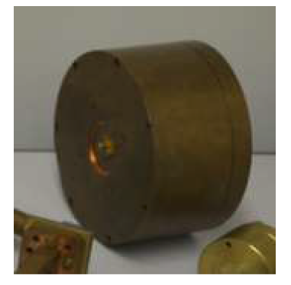
2.8 On a Smith Chart, report the measured S11 and the one obtained from the theoretical model, i.e. using Eq. 3 with the measured f0, Q0 and β (use the values in 2.7) (REPORT)

S band pillbox

3. PILLBOX CAVITY (S BAND): β > 1 MODE
Find the first mode in which at least one of the antennas is over coupled (it is the mode with f0≈5.6GHz). Choose an appropriate frequency range and calibrate the reflection measurement with 1-port calibration (as done for TM010 mode).
3.1 Measure the resonance frequency f0, the unloaded Q0 factor and the coupling coefficient β1, measuring from the over coupled cavity antenna. Verify the coupling from the Smith Chart and write it in the report. Use the impedance conversion (and the automatic bandwidth) for measuring Q0 and the VSWR for the measurement of β. Report also the values of f0, β and Q0 obtained with the routine ReflectionFitResonance.m (REPORT)
3.2 Plot |S11| measurements and the theoretical predictions, using Eq. 1 with the measured values in 3.1 (use MATLAB). On the x-axis of the plots use the normalized deviation from the resonance frequency δ (as shown in the lectures) (REPORT)
3.3 Using the memory function of the instrument, compare the reflection measurement while leaving open the other antenna to the measurement with the antenna being terminated with a load of 50Ω. Use in the report the screen shot of the instrument (PNG file). (REPORT)

4 X-BAND MULTI-CELL CAVITY
The multi-cell cavity is a full scale (1:1) prototype of a cavity used to manipulate an electron beam in a linear accelerator. The operation frequency is 11.424GHz. The waveguide couples the central cell to the RF source and it is designed to a have no RF power reflections (i.e. critical coupling) at the operation frequency.
There are different modes of the structure around the working frequency (theoretically one per cell).
Find the working mode and characterize it with the usual measurements (after the 1-port calibration in the proper frequency range). In particular:
4.1 Measure the frequency of all the modes close to the working frequency (from 11.2GHz to 11.44GHz) from |S11| (calibration not needed) (REPORT)
4.2 Measure the resonance frequency f0 of the critically coupled mode, the unloaded Q0 factor and the coupling factor β1 measuring from the waveguide port (calibrate a 30MHz span around the resonance frequency), using the impedance conversion. From the Smith Chart, verify the coupling and report it. Use the impedance conversion (and the automatic bandwidth) for measuring Q0 and the VSWR for the measurement of β. Report also the values of f0, β and Q0 obtained with the routine ReflectionFitResonance.m (REPORT)
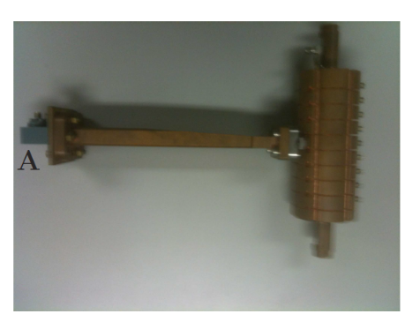
4.3 Plot |S11| measurements and the theoretical predictions, using Eq. 1 with the measured values in 4.2 (use MATLAB). On the x-axis of the plots use the normalized deviation from the resonance frequency δ (as shown in the lectures) (REPORT)

